Carbon Reduction Plan

Supplier Name | Vita Health Group
Author: | Vita Health Group – EDI & Sustainability Director
Published Date: | 01/05/2024

Contents

1. Commitment to achieving Net Zero 2

2. Baseline Emissions Footprint 2

3. Current Emissions Reporting 3

4. Emissions reduction targets 3

5. Carbon Reduction Projects 4

Commitment to achieving Net Zero
Vita Health Group is committed to achieving net-zero emissions by 2050*, in line with the UK Government’s Climate Change Act (2008). The Act was amended in 2019 to include a target of at least a 100% reduction in the net UK carbon account. Our commitments are also in line with the Greener NHS Campaign and ambitions outlined in the Delivering a ‘Net Zero’ National Health Service report (2020).

*VHG’s net-zero target is currently under review to better align with our parent company, Spire Healthcare, after the organisation’s acquisition in late 2023.

Baseline Emissions Footprint
Baseline emissions are a record of the greenhouse gases (GHG) that have been produced in the past and were produced prior to the introduction of any strategies to reduce emissions. Baseline emissions are the reference point against which emissions reduction can be measured.

Baseline Year: 2021
Additional Details relating to the Baseline Emissions calculations.
- Our GHG emissions from 1st January 2021 to 31st December 2021 resulted from the energy consumption at VHG’s facilities and its business transport activities.
- Our assessment was carried out by Carbon Footprint Limited.
- These figures constitute the base year for all further reporting emissions to be compared against.
- Data is available in both location-based and market-based format – the market-based is outlined in the table below, but for clarity, the totals for each are as follows: The total location-based carbon footprint for VHG for the period ending 31st December 2021 was 952.23 tonnes CO₂e, and the market-based total is 972.96 tonnes CO₂e.
- Intensity Metric 1: Tonnes of CO₂e per employee 0.97 / 1.00 (locations/market based)
- Intensity Metric 2: Tonnes of CO₂e per £M turnover 20.32 / 20.79 (locations/market based)
- Full methodology can be found here: https://www.carbonfootprint.com/docs/carbon_footprint_appraisal_-_methodology_document.pdf
- 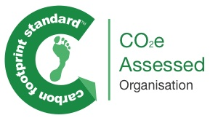
Emissions | TOTAL (tCO₂e)
Scope 1 | 71.66
Scope 2 | 42.63
Scope 3  (Included sources) | 858.66  (Home-workers, Computing, Commuting, Well to Tank, Non-Controlled Site gas, Waste, Non-Controlled Site electricity, Employee-owned car travel (grey fleet), Electricity transmission & distribution, Rail travel, Paper, Water, Taxi travel)
Total Emissions | 972.96

Current Emissions Reporting
Reporting Year: 2023
The total location-based carbon footprint for VHG for the period ending 31st December 2023 was 1,170.13 tonnes CO₂e, and the market-based total is 1,177.10 CO₂e.
Emissions | TOTAL (tCO₂e)
Scope 1 | 22.97
Scope 2 | 16.14
Scope 3 | 1,137.99
Total Emissions | 1,177.10
Comments | - VHG, in conjunction with Carbon Footprint Ltd, has assessed its carbon footprint and has achieved a successful assessment of their 2023 Greenhouse Gas emissions. VHG has demonstrated a reduction of emissions per £M turnover by 36.0% and 26.0% when compared to the baseline and previous year’s assessment respectively.  - This reduction has been achieved alongside an increase in scope with the addition of more detailed business travel categories.  - The most significant market-based emission source is computing accounting for 36% of VHG’s carbon footprint.  - Intensity Metric 1: Tonnes of CO₂e per employee 0.85 / 0.86 (location/market based).  - Intensity Metric 2: Tonnes of CO₂e per £ million turnover 12.57 / 12.64 (location/market based).  - Full methodology can be found here: https://www.carbonfootprint.com/docs/carbon_footprint_appraisal_-_methodology_document.pdf  - 

Emissions reduction targets
In order to continue our progress toward achieving net-zero, we have adopted the following carbon reduction targets:

- Aim to align VHG’s emissions reduction strategy with the NHS roadmap to have a net-zero supply chain by 2045 (NHS direct operation net-zero by 2040).
- A 50% reduction in emissions per £M turnover/employee by 2030.
- A 90% reduction in emissions per £M turnover/employee by 2045.

A forecast of our reductions against these targets can be seen in the graph below:

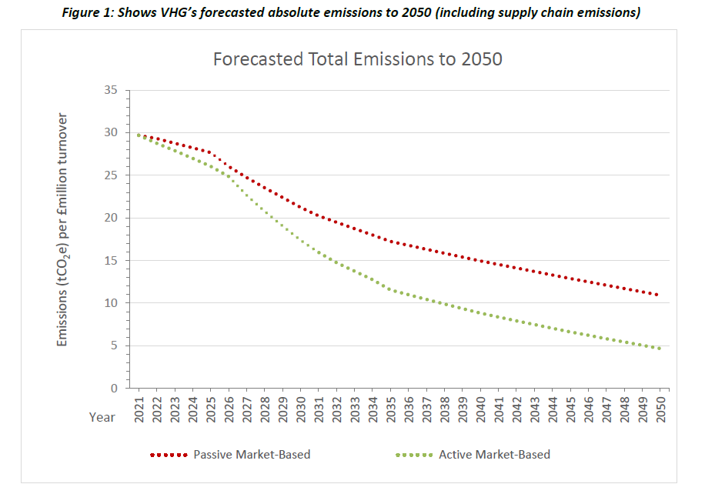

Carbon Reduction Projects
VHG Carbon Reduction Projects and activities include:

- Annual carbon emissions assessment.
- Completing the Energy Saving Opportunity Scheme (ESOS) assessment and implementation of the recommended energy reductions.
- Ongoing movement of VHG-controlled properties to sustainable/renewable energy suppliers.
- Minimisation of computer waste and utilisation of waste management suppliers who undertake carbon offsetting activities.
- Internal staff education on Carbon Literacy.
- Further investment in environmental sustainability expertise within the organisation with the creation of a Sustainability and Social Value Manager role.
- Evaluation of measures to improve supplier management environmental considerations.
- Improved monitoring of environmental risks.
- Improved premises auditing including environmental consideration.

In the future, we hope to implement further measures as outlined below.

Reduction of emissions from our estates where feasible by:
- Implementing ESOS energy-saving recommendations.
- Scaling back the physical footprint of our services facilitated via the increasing delivery of remote products.
- Improving building insulation and use of energy-efficient lighting and heating systems.
- Committing to move to sustainable suppliers where feasible.
- Ensure services are clinically effective to reduce the number of patient visits where appropriate.
- Implement robust monitoring.
- Developing Energy Policy.
- Providing energy efficiency training for all colleagues.

Reduction of emissions related to travel where feasible by:
- Prioritising ill health prevention to reduce the need to access services.
- Minimising emitting vehicle usage where feasible.
- Redesigning care pathways to maximise utilisation of remote services.
- Promoting active and sustainable travel for service users.
- Reducing barriers for staff to procure electric vehicles.
- Promoting active travel, with an internal Walking Challenge campaign.

Reduction of supply chain emissions where feasible by:
- Actively challenging suppliers on their carbon emission reduction planning.
- Reducing or eliminating the use of single-use plastics within our services.
- Implementing ESG questions in the supplier screening and selection process.

Increase staff competency around carbon literacy and engagement with the carbon reduction agenda by:
- Providing access to appropriately accredited training.
- Communicating carbon reduction plans appropriately.
- Providing appropriate resources and opportunities for staff to collaborate on carbon reduction interventions.
- Providing internal sustainability training as part of onboarding.

Declaration and Sign Off
This Carbon Reduction Plan has been completed in accordance with PPN 06/21 and associated guidance and reporting standard for Carbon Reduction Plans.

Emissions have been reported and recorded in accordance with the published reporting standard for Carbon Reduction Plans and the GHG Reporting Protocol corporate standard and use the appropriate Government emission conversion factors for greenhouse gas company reporting.

Scope 1 and Scope 2 emissions have been reported in accordance with SECR requirements, and the required subset of Scope 3 emissions have been reported in accordance with the published reporting standard for Carbon Reduction Plans and the Corporate Value Chain (Scope 3) Standard.

This Carbon Reduction Plan has been reviewed and signed off by the Executive Management Team.

Signed on behalf of the Supplier:

I Beckford (EDI & Sustainability Director)

Date: …………01/05/2024…………….…

